HSE Review – T-07 Gearbox Exchange Lift
Kestrel Ridge · KR-INC-2026-003
Hannah Weber · 10 February 2026 · KR-INC-2026-003-HSE

1. Scope
Review of the lift plan, risk assessment and method statement for the exchange of the T-07 gearbox at Kestrel Ridge following the failure on 14 January 2026 (KR-INC-2026-003), and observations during the lift on 2–5 February 2026.

2. Key risks and controls
Risk | Control
Crane instability on frozen / thawing ground | Ground bearing check (required 260 kN/m²), extra 210 t stone, steel outrigger mats, daily survey
Wind during lift | Limit 10 m/s mean / 12 m/s gust at hook height; anemometer on boom; two wind holds observed
Load swing / contact with tower | Two tag lines, experienced lift supervisor, no persons under load
Work at height in nacelle with roof open | Fall arrest anchors, roof edge protection, rescue kit on standby
Cold stress | Heated welfare unit at crane pad, 2-hour warming breaks, buddy checks
Livestock and public footpath | Sheep moved by landowner, footpath diversion signs, banksman at gate

3. Observations during the lift
- Good: daily pre-lift briefing with all parties; lift plan followed; stop-work used twice for wind.
- Near miss (HSE-INC-2026-005): one outrigger mat settled 40 mm on 4 February in thawing ground – lift paused, mats re-laid on extra stone.
- Improvement: radio channel shared with the landowner's tractor driver on the estate track – separate channel needed.
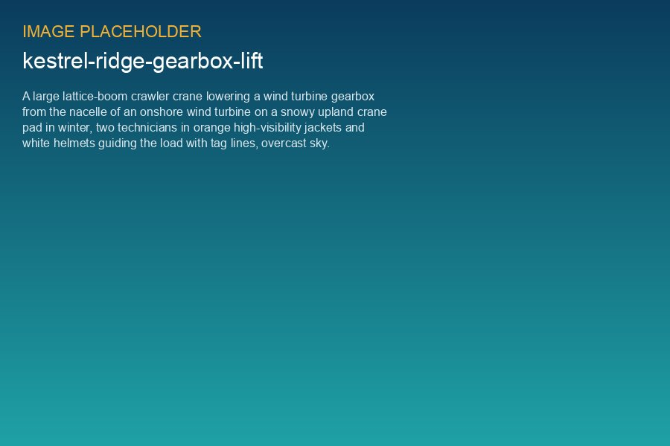
Gearbox lowered from T-07, 4 February 2026

4. Conclusion
The lift was completed safely with no injuries. The settlement of the outrigger mat shows that winter crane works on upland sites need a stronger ground design margin. This has been included in the Major Component Exchange Playbook (Asset Operations).

